# **Creating an AWS 3 Tier Architecture**

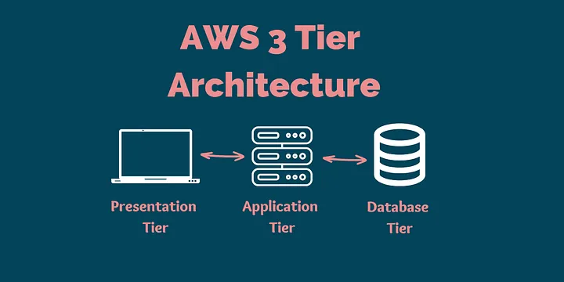

AWS 3-tier architecture and a step-by-step guide to creating your highly scalable AWS 3-tier architecture.

**The 3-tier architecture in AWS consists of the following layers:**

1. Presentation tier: Front-end web and application servers that handle user requests. It handles web servers, load balancers, and other components.
2. Application tier: Backend servers that process user requests and retrieve data from databases. It works as a mediator between the presentation tier and the data tier.
3. Database tier: Manages data storage and retrieval, typically through a relational database management system (RDBMS). It mainly includes databases, file storages, and other data storage services.

## **Benefits of using 3 Tier Architecture:**

1. **Improved scalability**: Each tier can be scaled independently, allowing for better performance under increasing load.
2. **Improved maintainability**: Modifying or updating one tier does not affect the others, making it easier to maintain the system.
3. **Increased security**: Sensitive information can be stored on a secure middle tier, reducing the risk of exposure.
4. **Enhanced performance**: The separation of concerns between the different tiers leads to better performance.
5. **Easier to manage**: Each tier can be managed by different teams, improving efficiency.
6. **Reusability**: Components in a tier can be easily reused in other applications, reducing development time.

**Steps to create a AWS 3-tier architecture:**

* Create VPC and Subnets
* Create an Internet Gateway
* Create a NAT Gateway
* Create route table
* Create security group
* Create EC2 Launch templates
* Create Auto Scaling Group
* Create Application Tier

## **Step 1 : Creating VPC (Virtual Private Network) and respective subnets**

In the AWS management console, go to the search bar and search “VPC” and click “Create VPC” so that you can see below the screen where you need to create a VPC.

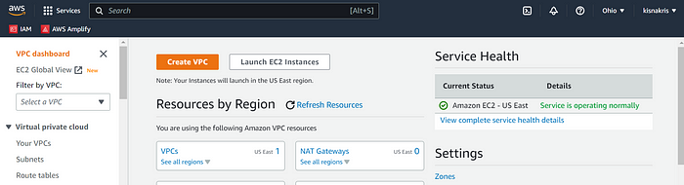

Now click on “Create VPC”. In resources to create you need to select “VPC only”. Give your VPC a name, I have given “vpc1”.Leave the default IPv4 CIDR manual option, and leave all other options default. Now we will manually select our CIDR block.

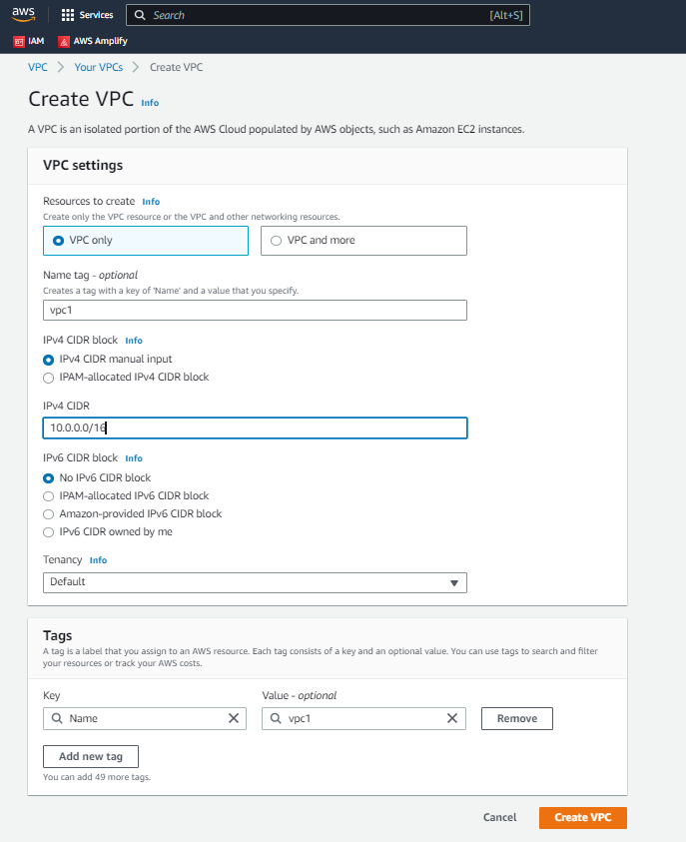

You can see VPC has been created, below is the confirmation.

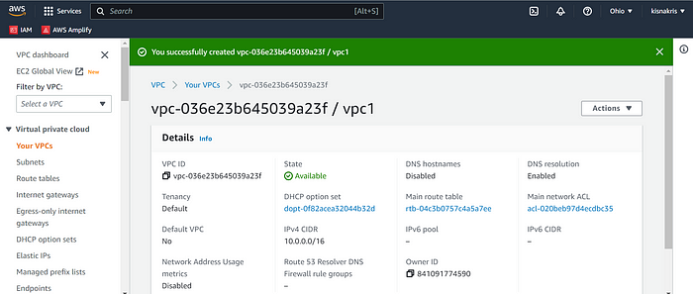

Now we have to create an Internet Gateway. On the same screen, navigate to the left and click on “Internet Gateway.”

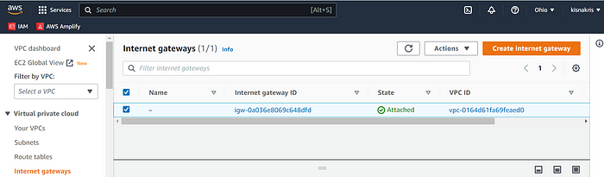

There is already a default Internet gateway attached to the default VPC, still we need to create a new Internet Gateway. So click on “Create Internet Gateway” on the top right of your screen.

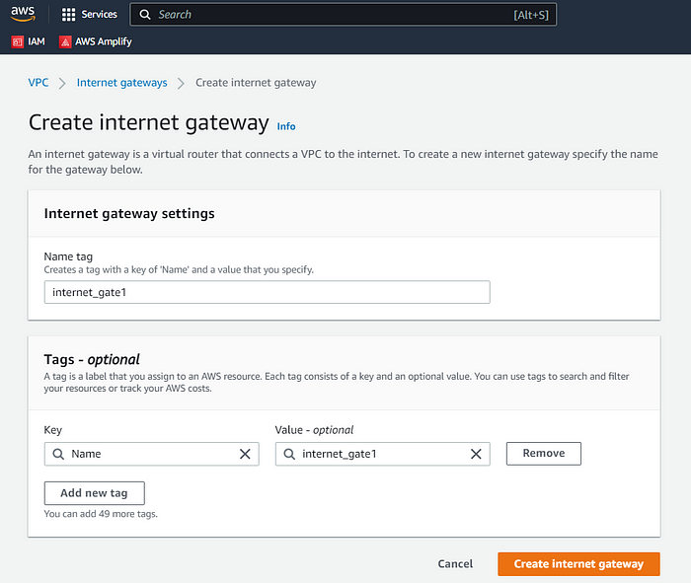

Name your internet gateway. I named it “internet_gate1”. and click on “Create Internet Gateway”.

The internet gateway is created and now we will have to attach the same to the newly created VPC.

Select the internet gateway and click “Attach to a VPC”.

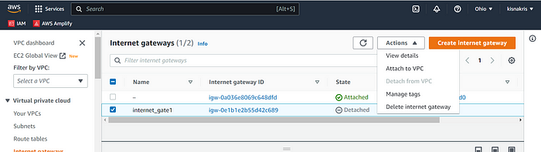

Now you need to select the newly created VPC from the dropdown. After selecting click on the “Attach internet gateway” tab there.

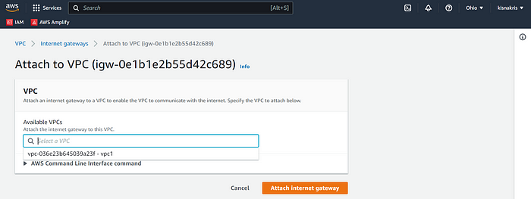

You can see the “green” banner confirmation that Internet gateway was successfully attached to the VPC.

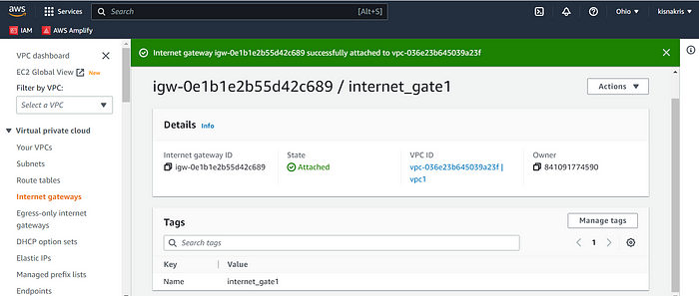

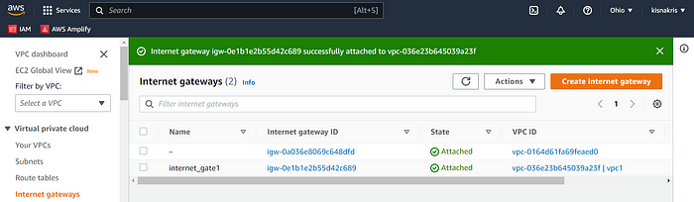

Internet gateway attached to VPC

After attaching internet gateway to newly created VPC, now we need to create our subnets. Here we will need total 6 subnets. 2 public subnets, and 4 private subnets. Navigate over to the left of the dashboard, and select “Subnets” in the top right click “Create subnet.”

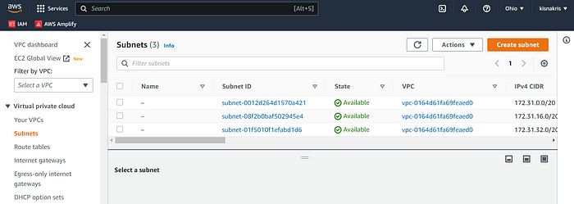

Now create 2 public subnets. Select the newly created VPC to create these subnets. Put the name of the subnet, IPv4 CIDR and Availability Zone.

**\*pub-subnet1**

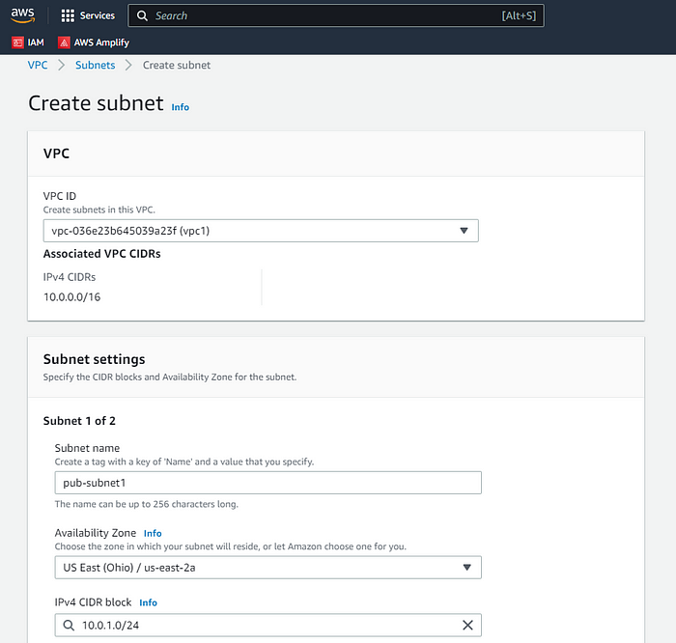

**\*pub-subnet2**

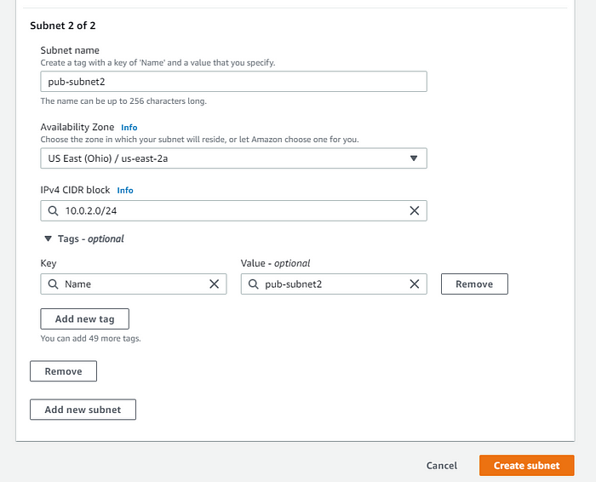

Click on “Create Subnet” you will get your two newly created public subnets.

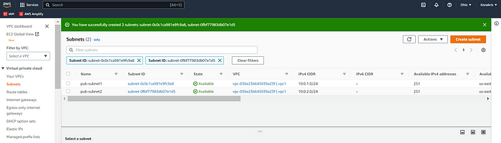

Now we will create 4 private subnets. Follow the same procedure.

**\*pvt-subnet1**

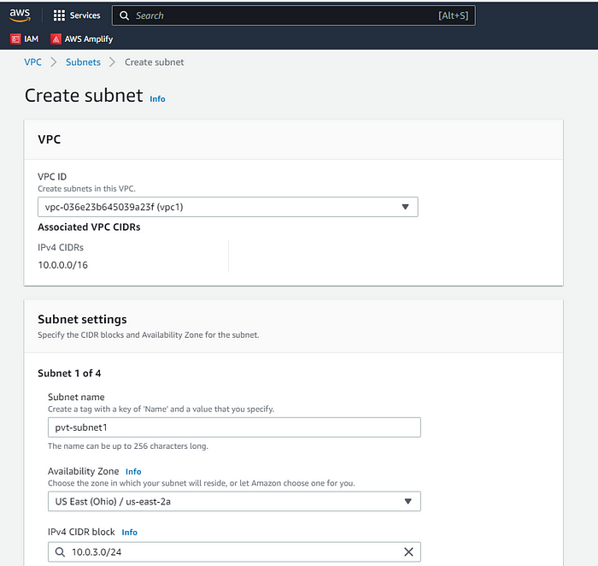

**\*pvt-subnet2**

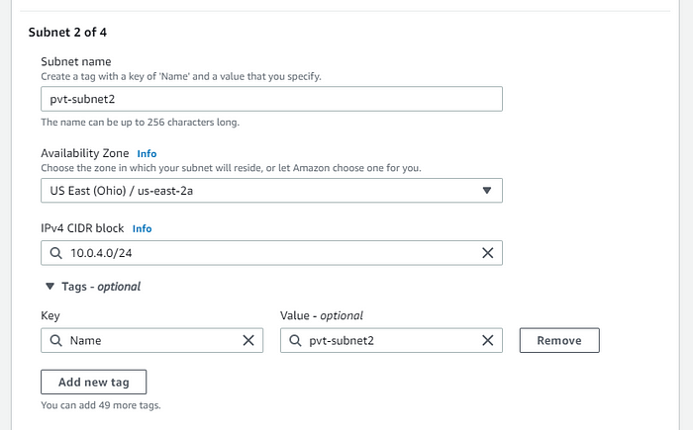

**\*pvt-subnet3**

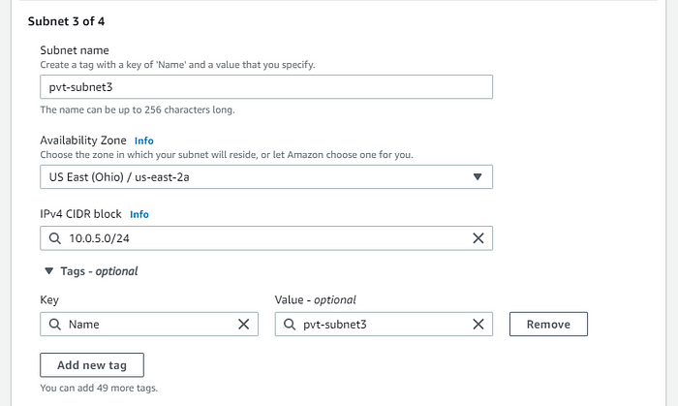

**\*pvt-subnet4**

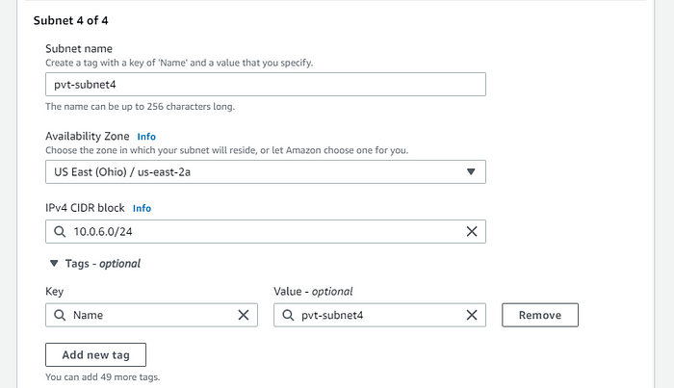

Click on “Create Subnet” you will get your four newly created private subnets.

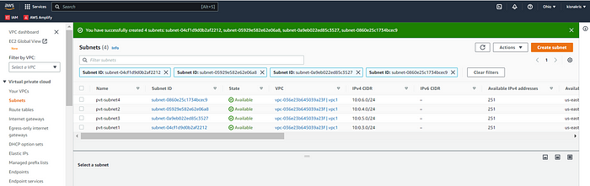

You can see all the six subnets created.

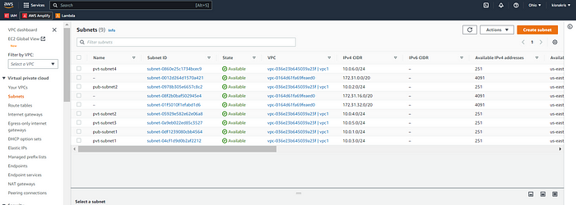

Next we have to create a NAT gateway.

**NAT gateway :**

Navigate over to the left dashboard, select NAT gateways, and click “NAT gateway.”

**A NAT (Network Address Translation) gateway** is a device that allows an entire network to share a single public IP address. The NAT gateway acts as an intermediary between the internal network and the public internet, forwarding requests from internal devices to the internet and sending responses back to the internal devices.

This allows internal devices to communicate with the internet while preserving their privacy and security, as the public IP address of the network is hidden behind the NAT gateway.

Now navigate to the left dashboard, select NAT gateways, and click “NAT gateway.”

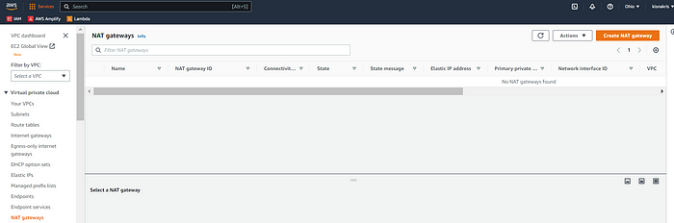

Give a name(pub1-nat-gate) to your new NAT gateway, and select a public subnet . Select your connectivity type and allocate an Elastic IP and click “Create NAT gateway.”

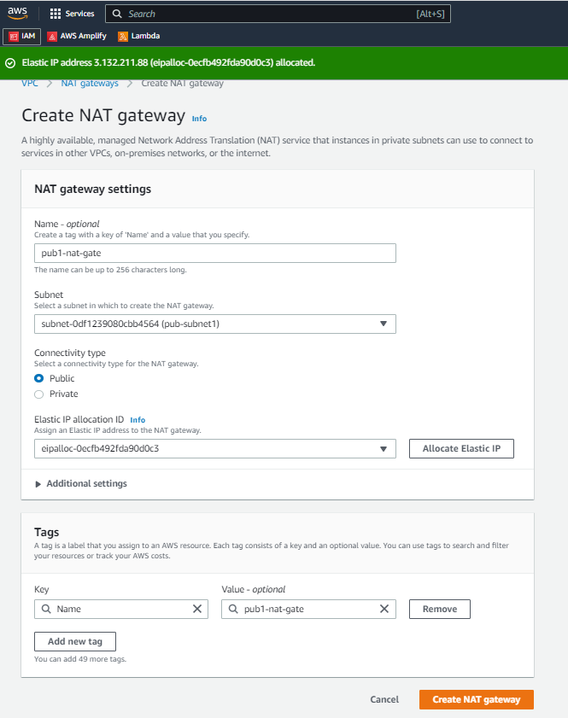

NAT gateway is created.

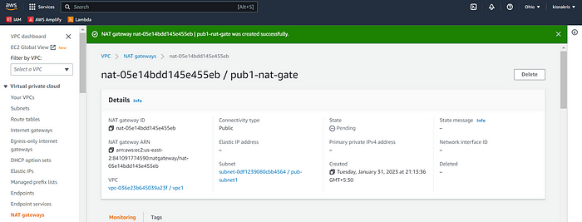

Next we will create a public route table. Navigate to left dashboard and click on “Route tables” to create one.

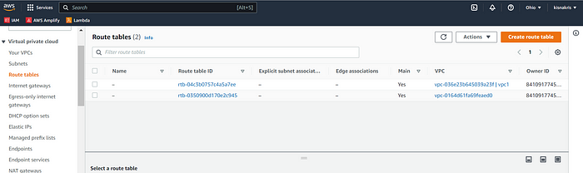

Now give a name to your route table and select your VPC. Click “Create route table” at the bottom.

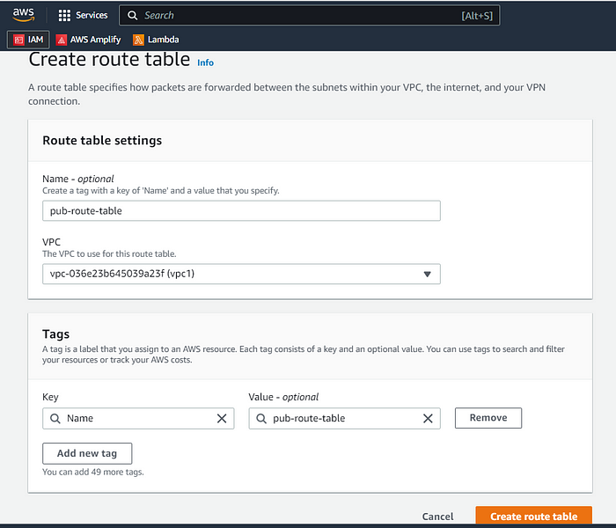

Route table has been created, we got the confirmation.

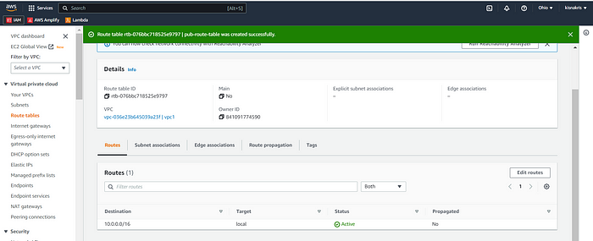

Now click “Edit route” and then click on “Add route.” Now add 0.0.0.0/0 as destination, and select the Internet gateway that you just created and click on “save changes”.

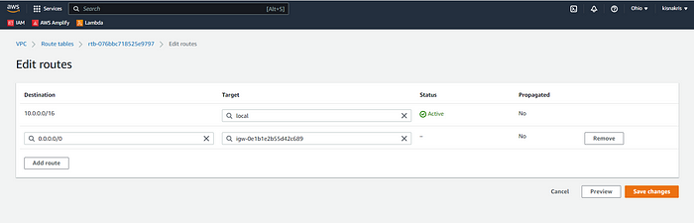

You can see “Route Table” has been updated successfully.

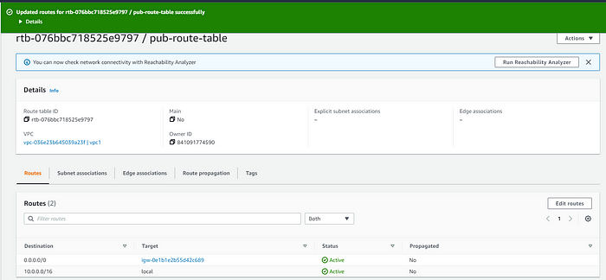

Now we need to associate our two public subnets (pub-subnet1, pub-subnet2) with the route table. Select the tab “Subnet associations,” and the click “edit subnet associations.”

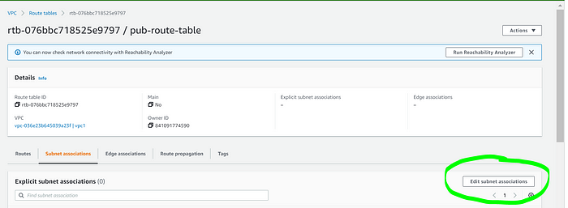

Select the two created public subnets and click on save association.

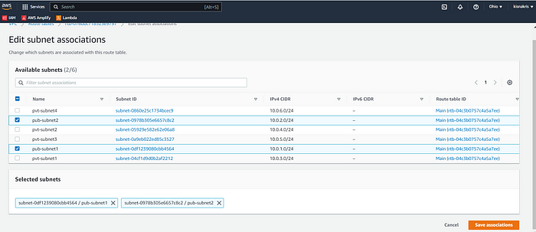

After this you can see the confirmation of subnet associations associated with the route table

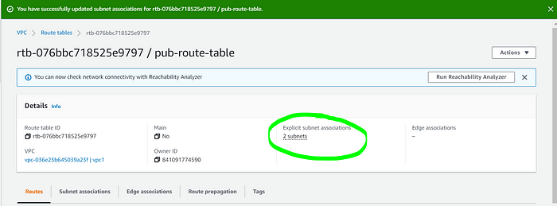

Part 1 of the setup , including VPCs, subnets, and routing tables etc has been completed .Now lets move on to the Part 2 of Web Server Tier.

In this part we will create the “presentation tier” i.e. the front-end user interface. We will start with the Security group first. Navigate over to the dashboard on the left, under security section select “Security groups.”

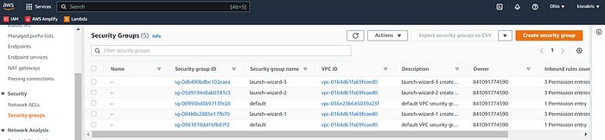

Give a name to the security group, add description, set traffic parameters, and click the “Create security group” tab.

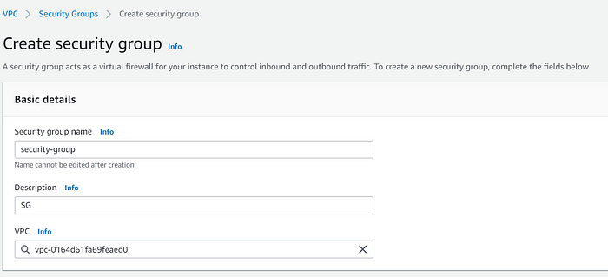

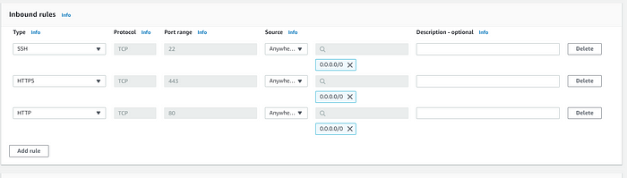

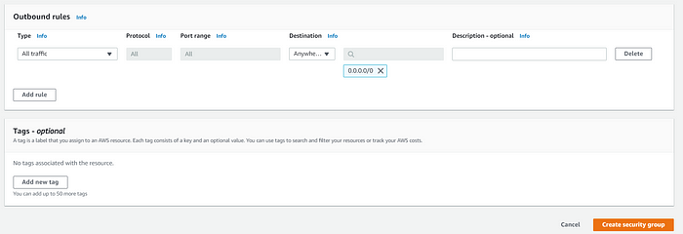

You will get a confirmation saying “security group cretaed”.

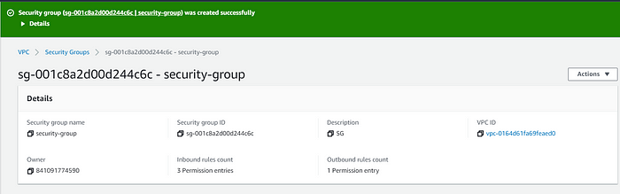

Now we can configure our EC2 image. First we will create a launch profile. Navigate over to EC2 dashboard. On the left dashboard, under Instances section, select “Launch templates.”

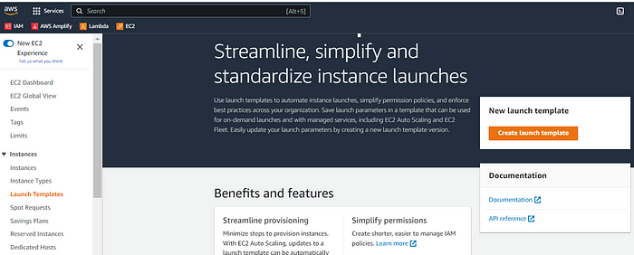

In the launch template, Put a name, add description, enable auto-scaling guidance, select your Amazon Machine Image (AMI), and select your architecture.

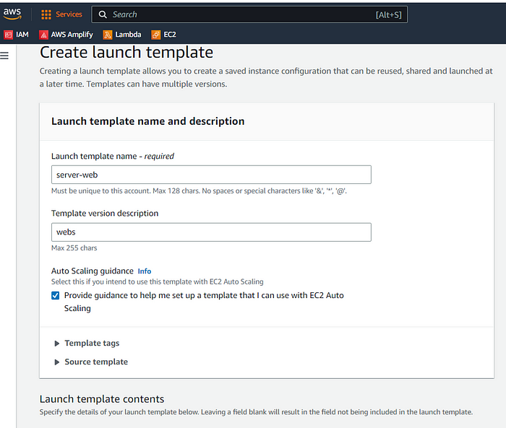

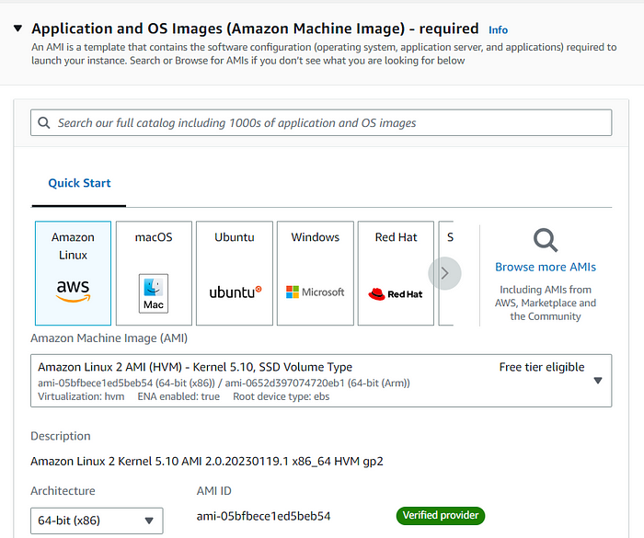

Next, select your instance type, create key pair, and add security group. Enable an “auto-assign public IP.”

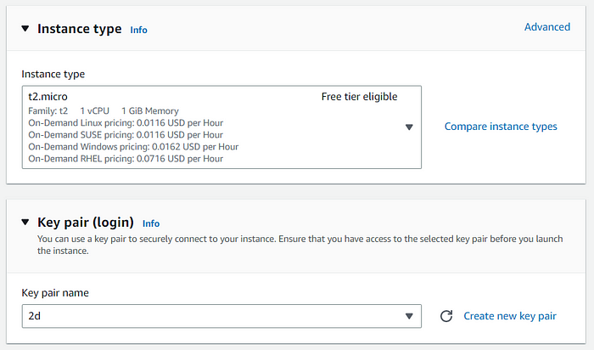

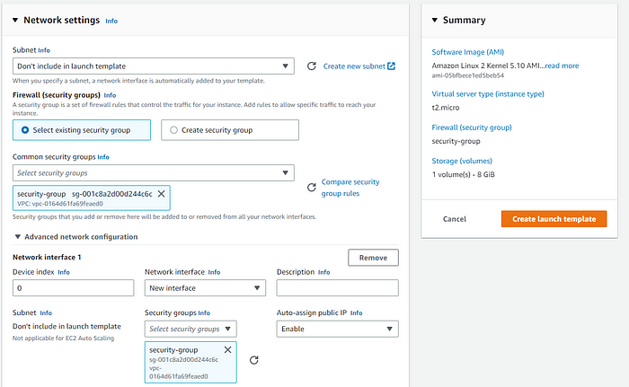

Add this user data code by selecting “Advanced Details” tab.

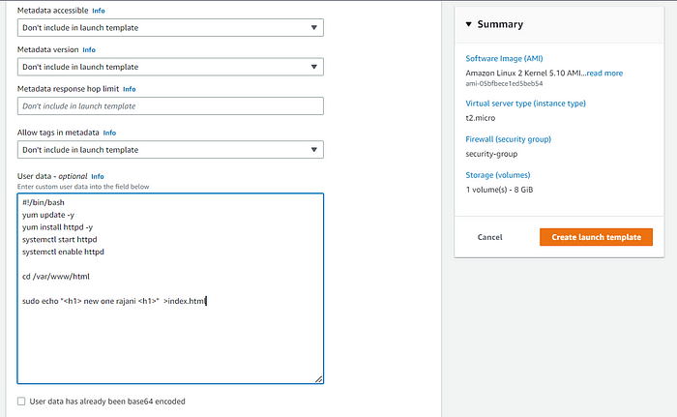

Now you are all set to click on Create Launch template.

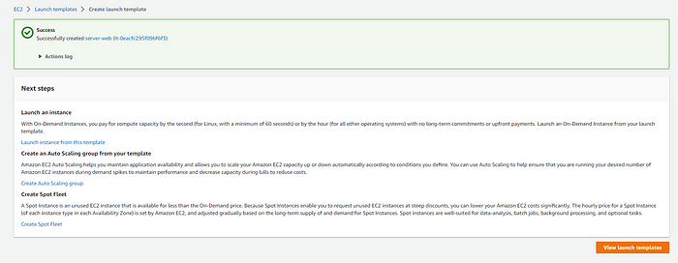

Go to the Launch template created and create an EC2 instance from it.

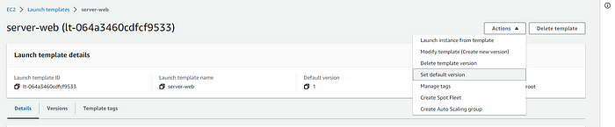

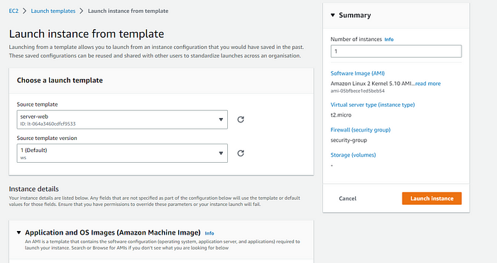

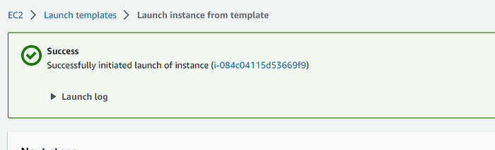

Click over to the EC2 Dashboard, and you will see your EC2 instance running. Copy the public IPv4 and paste into your web browser to see your custom webpage.

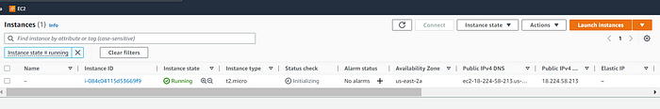

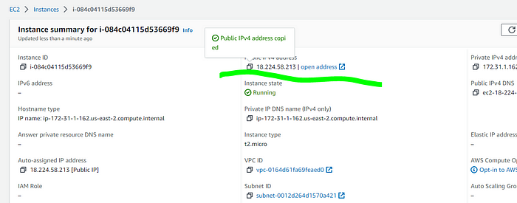

We got the output that means we have configured all the things correctly.

Now we will continue the web tier steps. First, create an auto-scaling group, then a load balancer, and last a target group. In the EC2 dashboard, navigate over to the left dashboard, selection “Auto Scaling Groups” at the bottom. Click the orange “Create Auto Scaling group” tab.

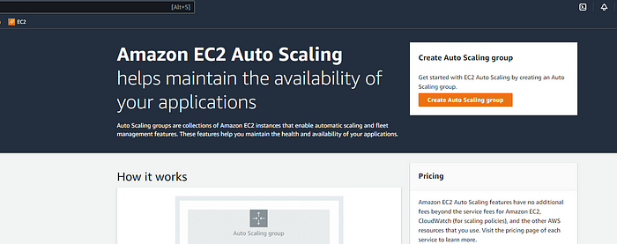

Give a name for your ASG and select your launch template we created earlier. Click “Next.”

Step 1 :

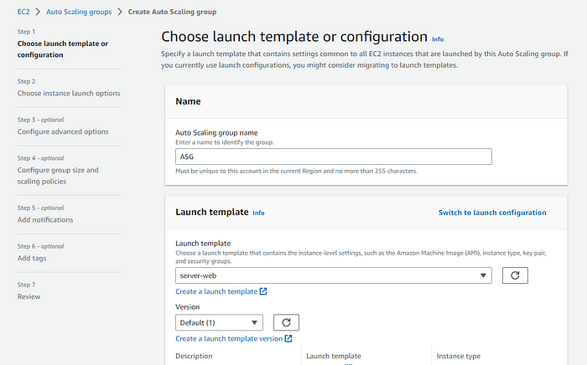

Step 2 :

Here we will select our VPC we created and select our two public subnets. Click “Next” once done.

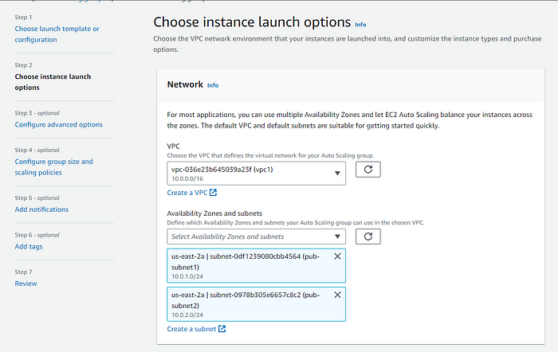

Step 3 :

Now “Attach a new load balancer. Select the application load balancer and give it a name. For load balancer scheme, select “Internet-facing.” We want the capability to direct traffic from the Internet. For network mapping, our VPCs with two subnets should already be selected.

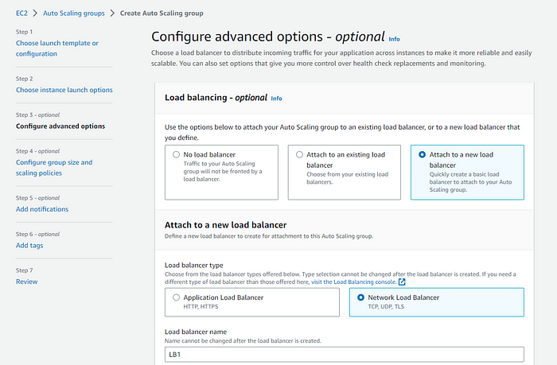

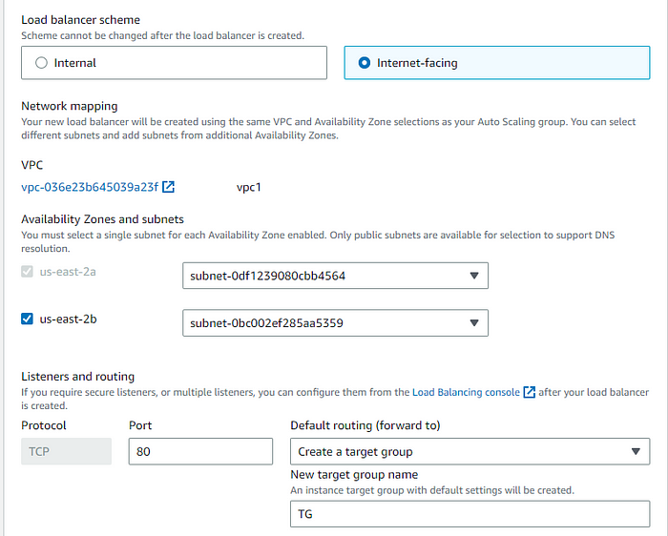

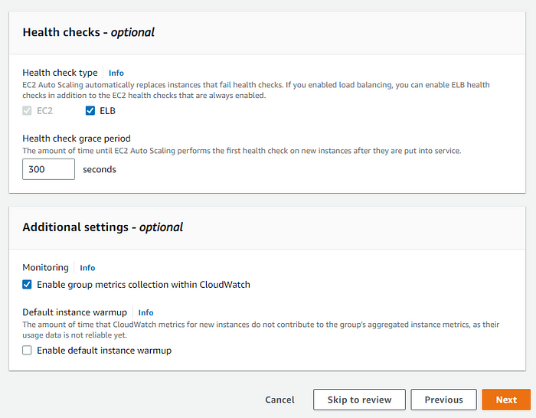

Step 4 :

We are going to set our configuration group size and scaling policy parameters.

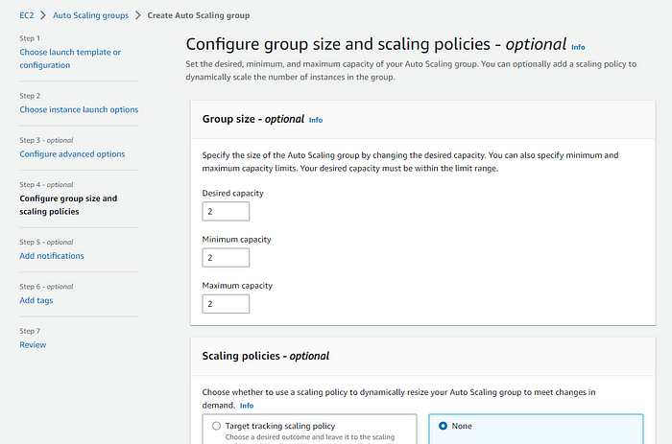

Skip Step 5 and 6 :

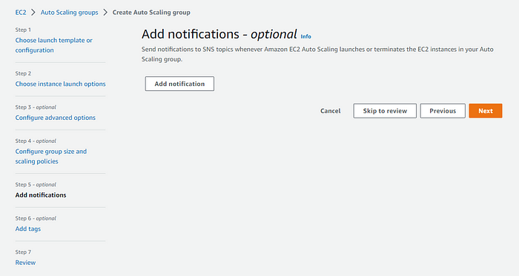

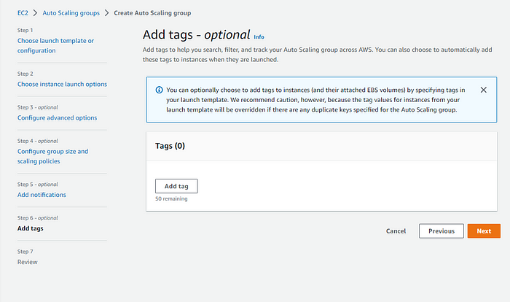

Step 7 :

Review and create the ASG.

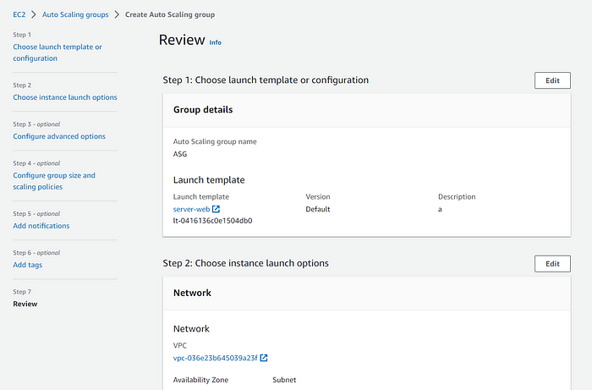

You can see ASG has been created.

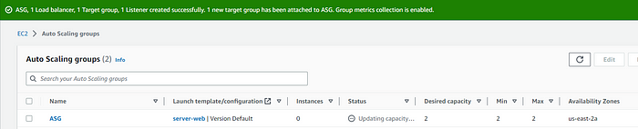

Please check the EC2 dashboard for two running EC2 instances.

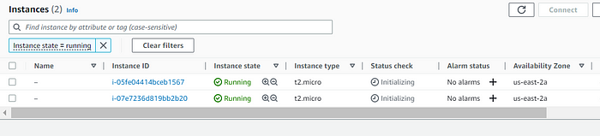

Copy and Paste IPv4 and check the output.

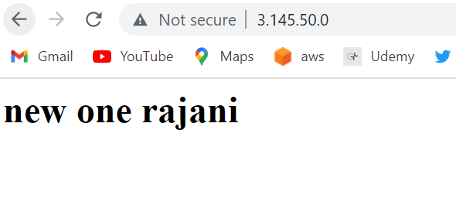

Presentation tier is completed now. Lets move to the application tier.

**Part 3: Create Application Tier**

Here we will be creating a VPC just like we did in the presentation tier. But this time for two of the private subnets created. We will also be creating EC2 instances, with auto scaling groups. We will create a new security group configured to limit access from the public, since these subnets will be.

Let’s jump over to the VPC. Navigate over to left dashboard to “Security Groups,” and click “Create new security group.”

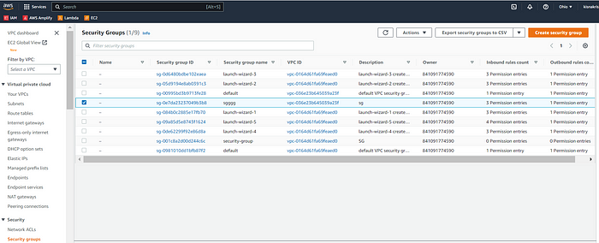

Give a name to your security group. Add a description and select your VPC. For Inbound rules, we are going to enable SSH traffic, set a custom TCP to our tier 1 security group, and add “All ICMP — IPv4, so we can ping out from the application tier to the Internet.

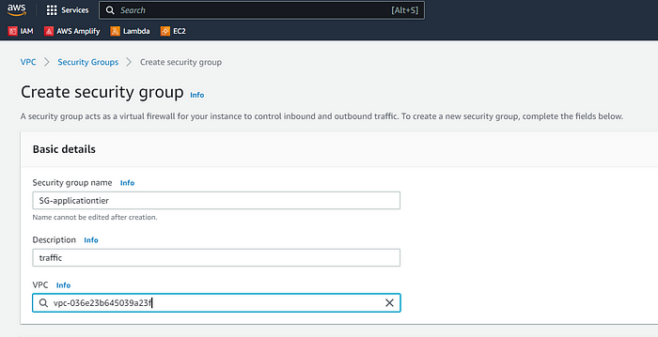

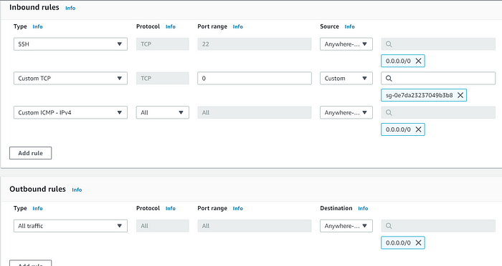

Security group successfully created.

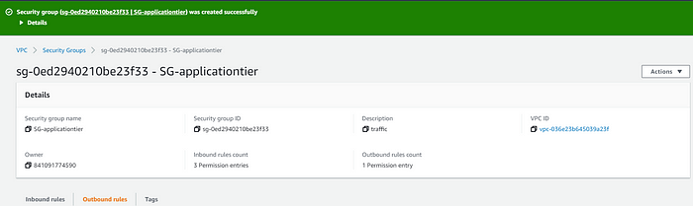

Next we need to setup the launch template. Biggest difference from tier 1 is the security group. Once all settings are updated with new security group, click “Create Launch template.”

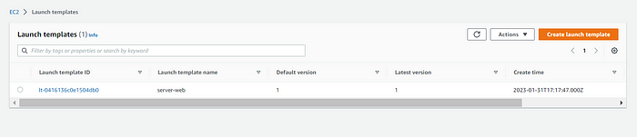

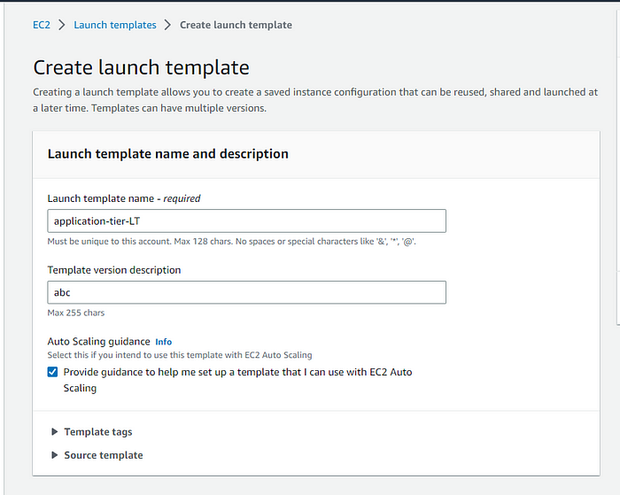

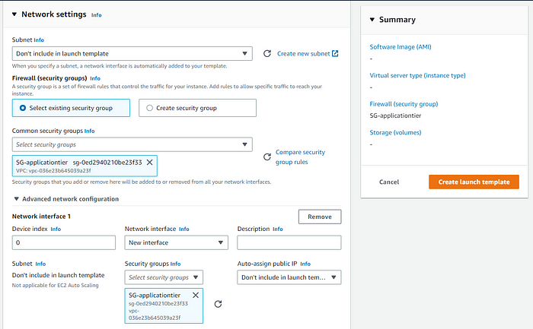

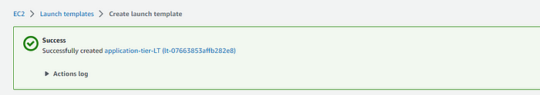

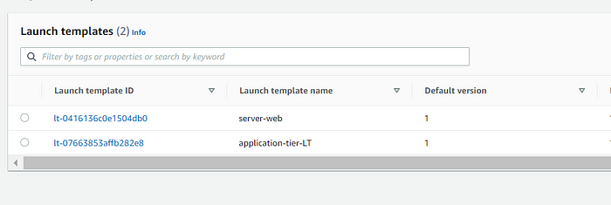

Once the Launch Template is created . Now move on to creating Auto scaling, Load balancer, and Target Group. Within the EC2 dashboard, select Auto Scaling Group and click “Create an Auto Scaling group.”

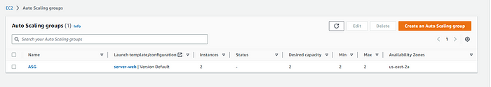

Put the parameters with updated security group.

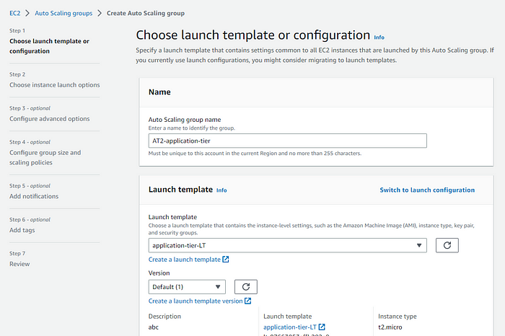

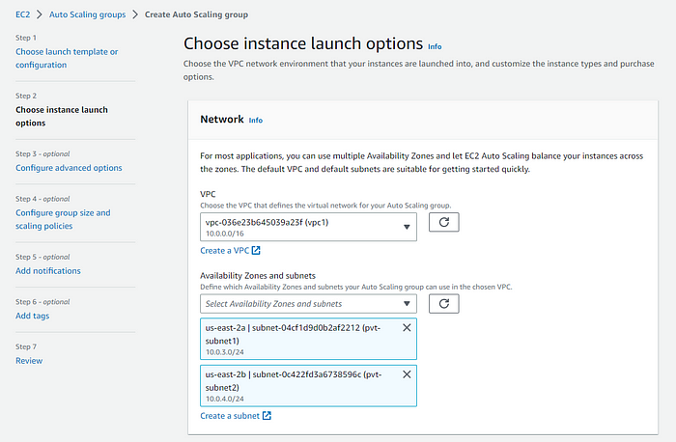

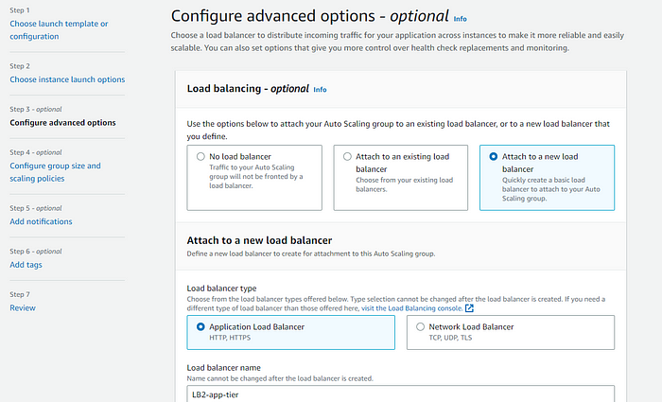

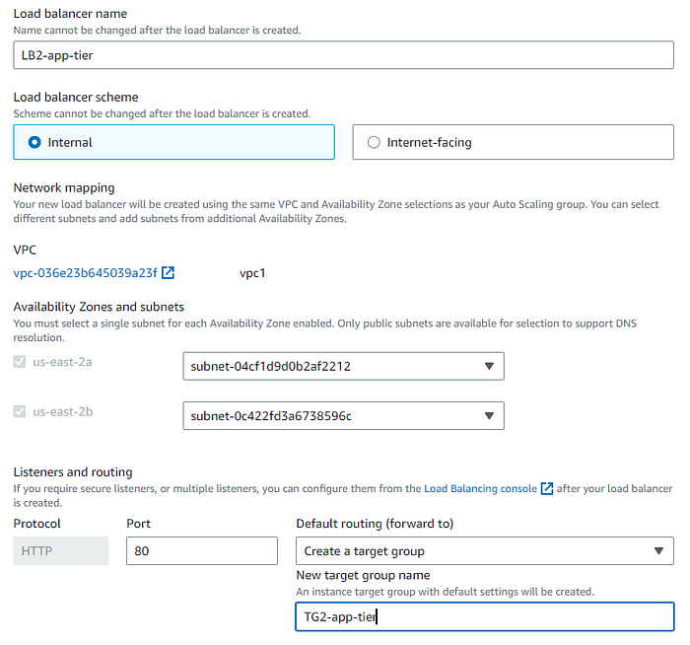

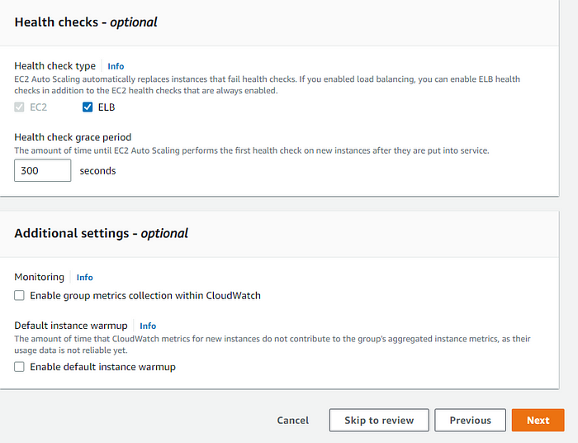

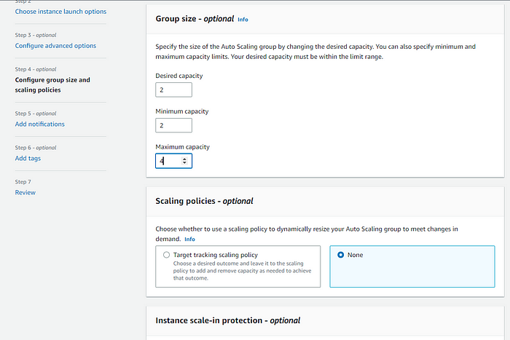

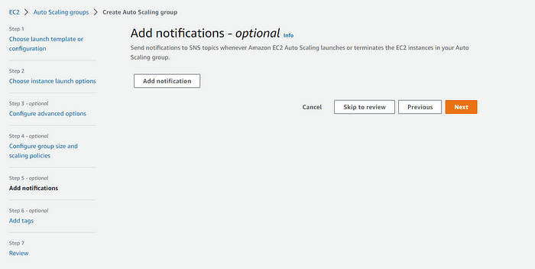

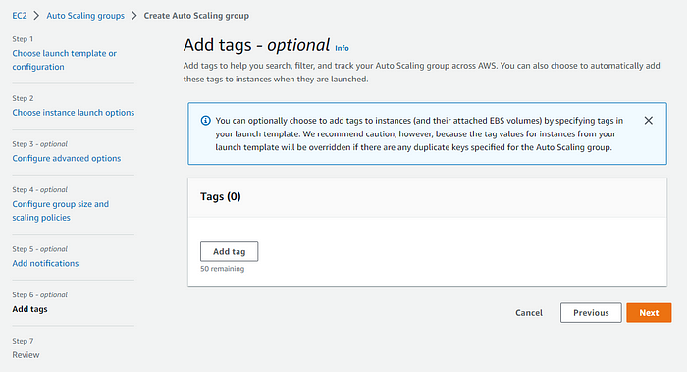

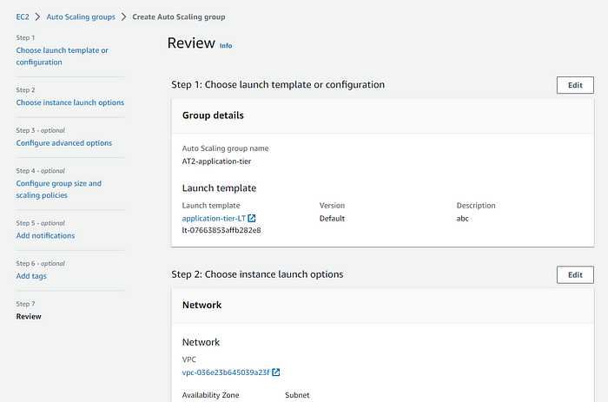

ASG is successfully created. Shift to the EC2 dashboard to confirm EC2 instances are provisioned.

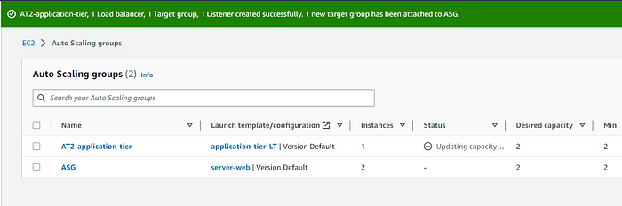

You can see two new machines being created.

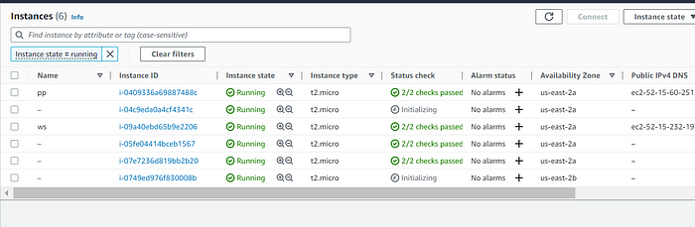

Now we will create the private route tables. Head over to VPC dashboard, in the Route tables section, click “Create route table.”

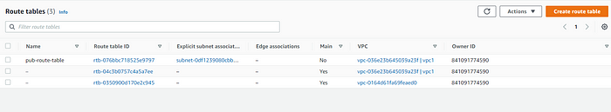

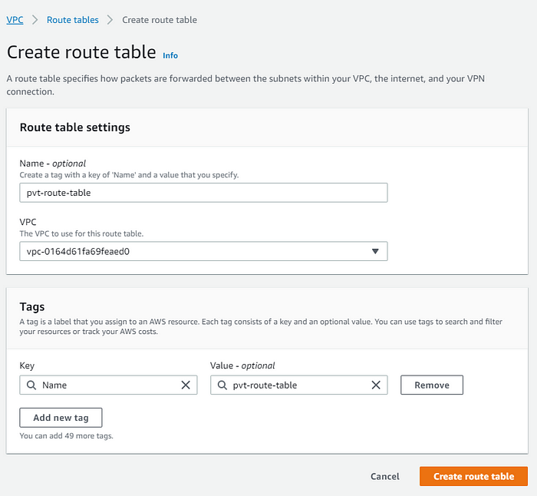

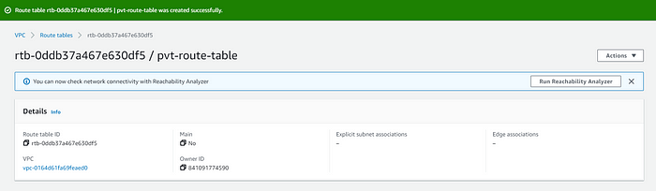

Now go to the Route table dashboard, and select the private route table you just created, click the subnet associations tab, and click “Edit subnet associations.”

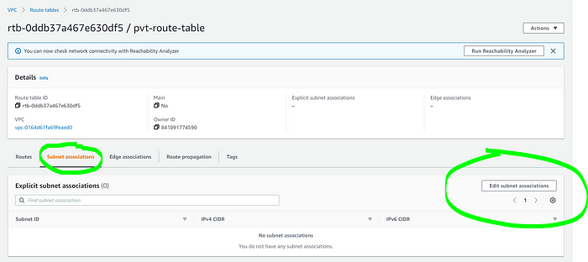

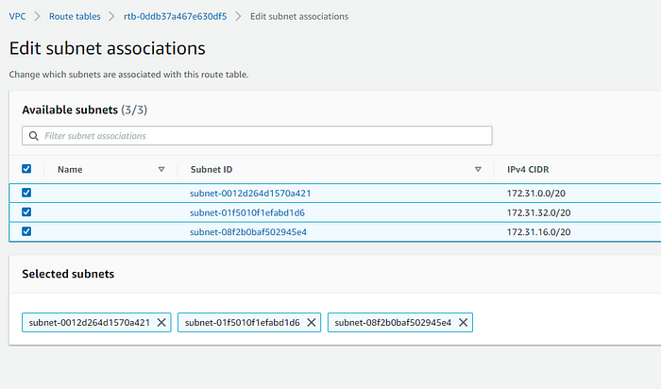

Successful confirmation page.

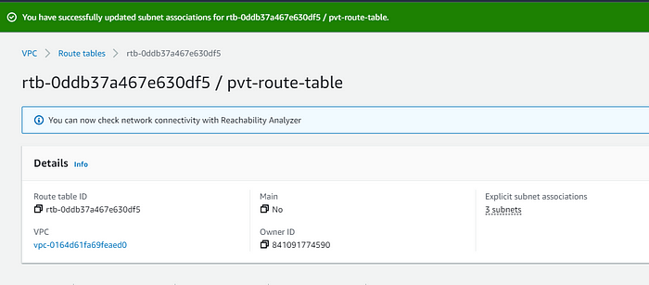

We won’t be able to access the machines creted because the application tier is not “Internet facing”.

**Part 4:**

**Create Database Tier**

Now we will build our 3 Tier i.e. “Data Tier”

We will create a Relational Database (RDS). It can read, write, and store data.

Move to VPC dashboard and select “Security groups,” then click “Create new security group.” Come up with security group name, description, and select VPC. For Inbound rules, this time we will select MySQL/Aurora. Put Application Security group from the 2nd tier.

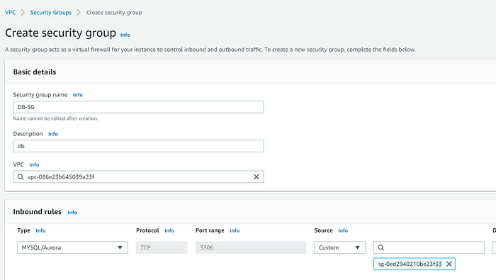

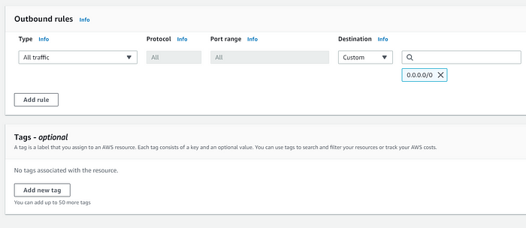

Security group has been created.

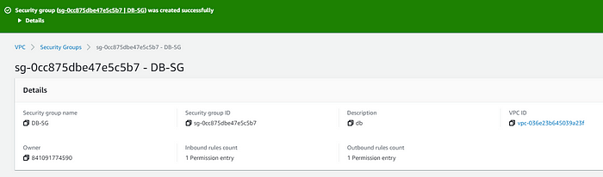

Now we will create a DB i.e. RDS.

Go to the search bar and type RDS.

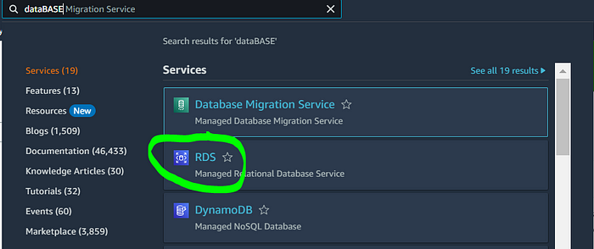

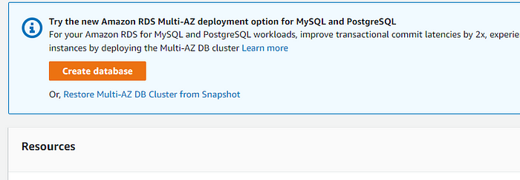

Choose “Standard create” and select “Engine Type” Amazon Aurora, “Edition” Amazon Aurora MySQL-Compatible. We will select “Production” as the template.

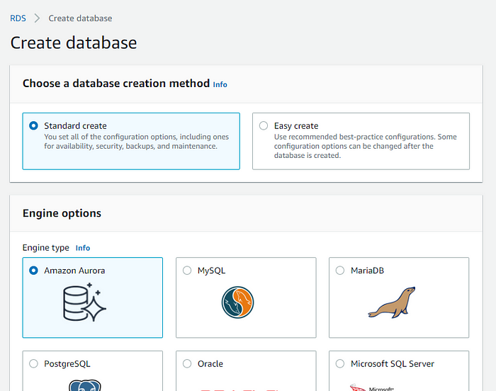

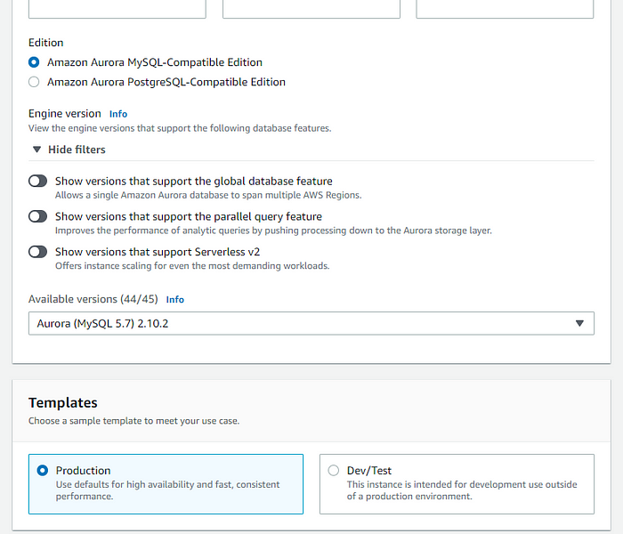

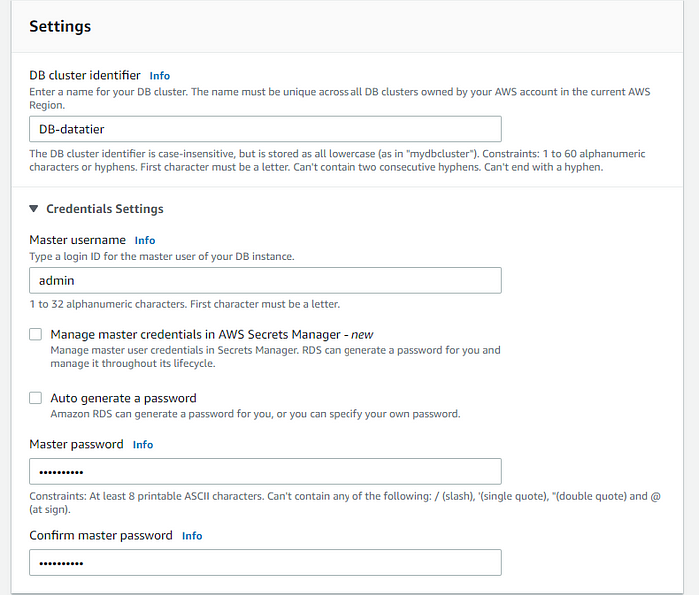

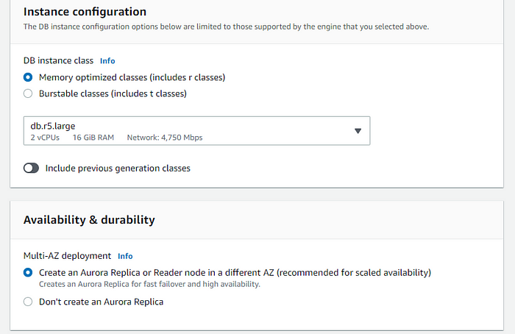

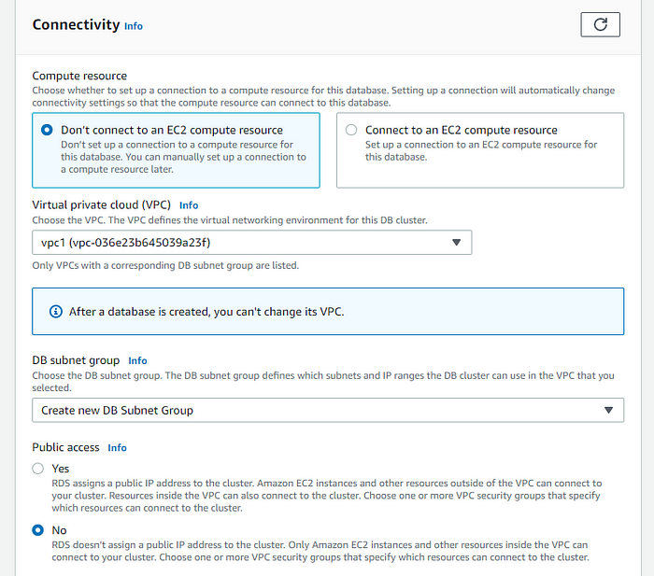

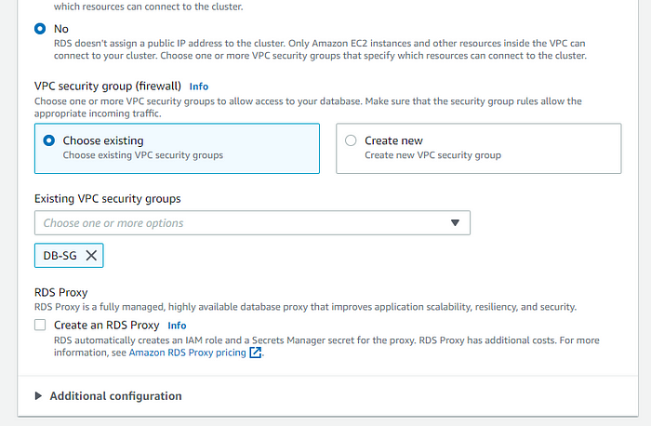

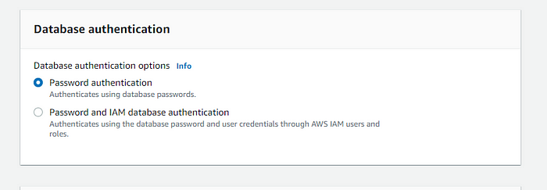

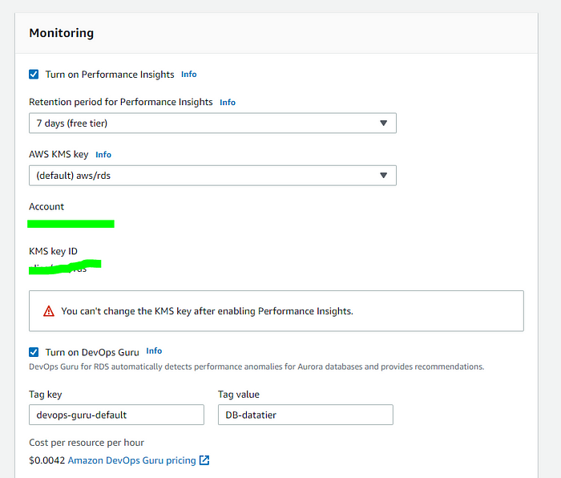

Click “Create database”

Database was successfully created.

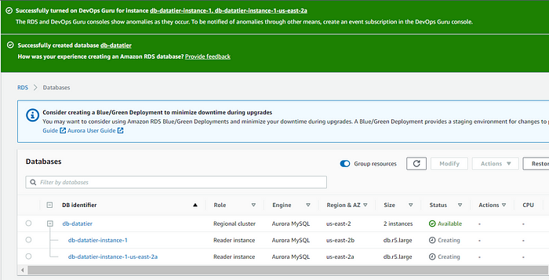

Click “View connection details” to know database username and password you created. Also you can copy your database cluster Endpoint. Will use this information to connect our application instances with our database.

Head to RDS dashboard, and select the database we just created. Click the actions drop-down menu, and click “Set up EC2 connection.”

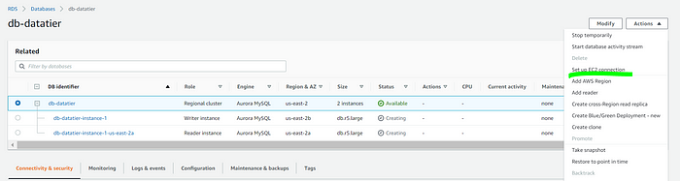

Choose an machine created from the application tier.

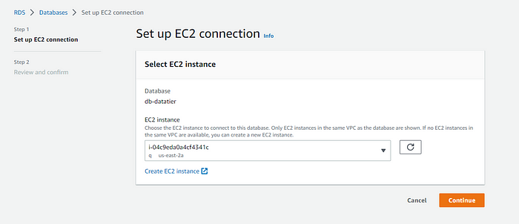

Click “Confirm and setup.”

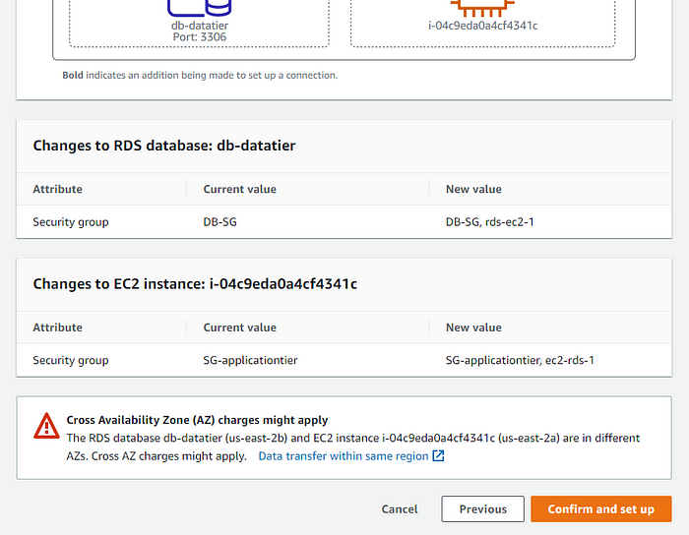

It is created successfully.

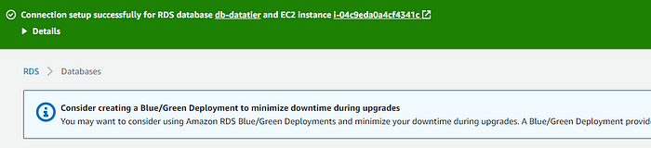

**Part 5:**

**Test the Tier 3 Architecture**

**SSH to Tier 1 Instance**

Now we will test the connection between application tier to our relational database.

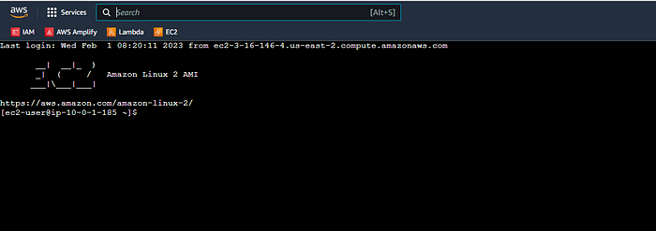

**Ping Tier 2 from Tier 1**

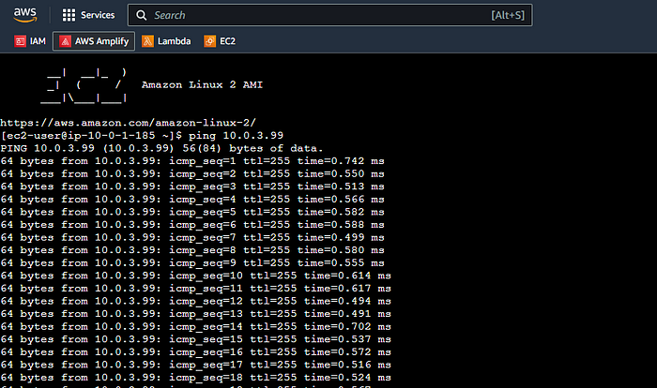

The ping is successful.

**Access Private Subnet from Public Subnet**

#ssh-add -K <keypair.pem>

use this command.

SSH into the public web tier 1 EC2 instance.



Log into public EC2 instance. Use the following command.

#ssh-add -l

Now that our key pair has been forwarded to our public EC2 instance, lets test our connection to the private instance containing the RDS database.



use command

#sudo yum install mysql -y

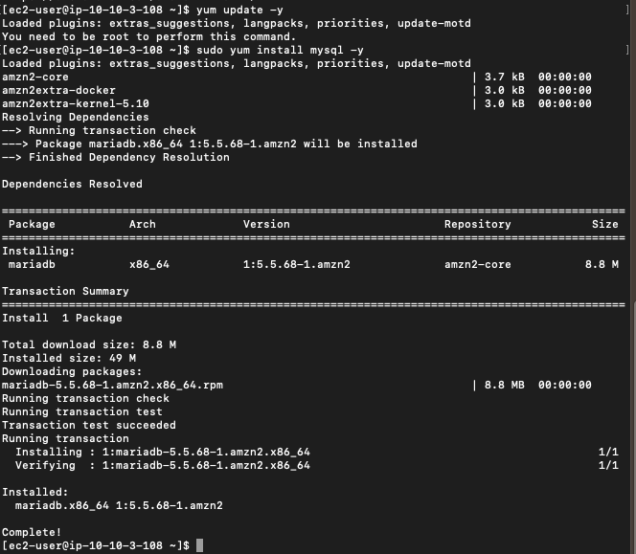

Log into our RDS with the following command.

#mysql -h <rds-database-endpoint> -P 3306 -u <username> -p

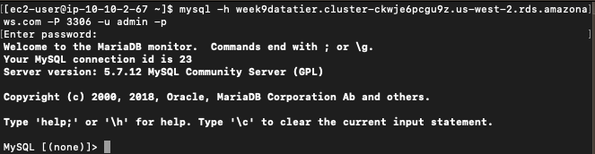

You are now connected to your MySQL RDS. You have just built a 3-Tier Architecture in AWS.